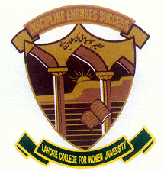

DEPARTMENT OF ELECTRICAL ENGINEERING
COURSE NAME: Power electronics | TERM: Fall 2020 | Assignment no. 1  CLO-1  P1
COURSE CODE: EE 331 | SEMESTER: 6 | Date of issue:24th Jan,2020
RESOURCE PERSON: Ms. Nausheen Bilal | SESSION: 2017-2021 | Date of Submission: 20th Feb,2020

Sr. no | Questions
1. | What is MOSFET?  Describe its:  - Construction  - Working
2. | Explain the following modes of MOSFET:  - Enhancement mode  - Depletion mode

